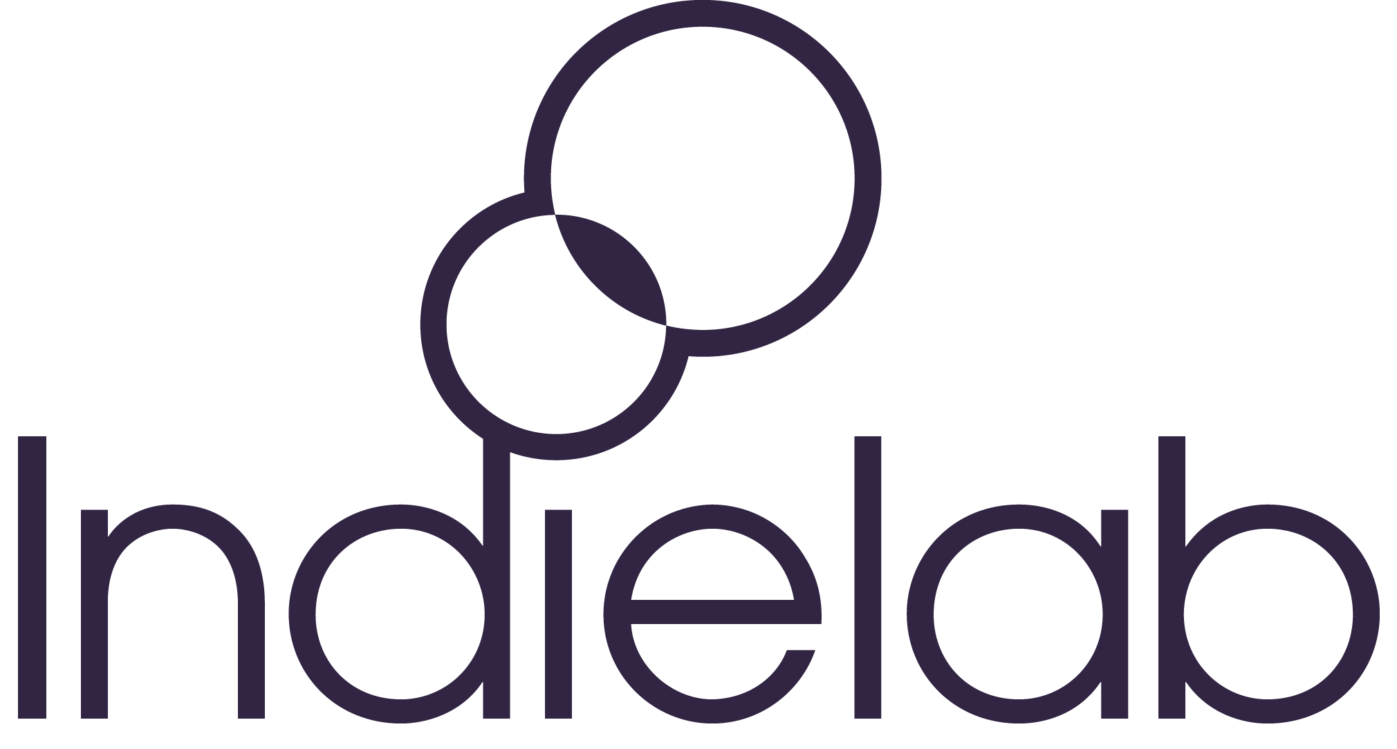
INDIELAB 2022 TV ACCELERATOR
Application Form
Indielab is delighted to open applications for the 2022 TV Accelerator, and we look forward to hearing from you.

Before completing this form please visit our website, particularly the Apply, Criteria and FAQs sections, which give full details of the programme and the application criteria.

If you would like a large print version of this application form, or if you require any adjustments or alternative arrangements for applying, please contact Matthew Poxon, Programme Manager: matthew@weareindielab.co.uk

Name of person completing form: |  | Email address of person completing form:
Company name: |  | Company number:
Number of company employees:
Website: |  | Twitter handle:
Short company biog (approx. 100 words):
Do you encourage diversity and inclusion in your company? If so, please give details:

For every company that takes part in the TV Accelerator, we offer two places. These places are specifically for founders and senior leadership team members responsible for company growth. If your company is selected to take part in the TV Accelerator, please give details below of the one or two team members who would take part.
Delegate One
Name: |  | Position within company:
Email: |  | Mobile:
Delegate Two
Name: |  | Position within company:
Email: |  | Mobile:
Head office address (please also state where in the UK your company is based, if different from the head office). If you do not have a physical company office, please note below the location where you carry out most of your work.

Please briefly describe the range of content your company makes, and in which genres. Please specify whether the work is scripted, non-scripted or both:
To meet our criteria you must have two company TV credits in the last two years. Or for start-ups, three founder TV credits as a producer, executive producer or series producer in the last three years.

Please list these credits below. If you are a start-up, please include the founder’s specific credit on the project:
Please list the programmes you have delivered in the last 18 months:
Please list the programmes you expect to produce in the next 12 months:

Please provide revenue figures for your last financial year.
Total revenue: |  | Export / international revenue  (international commissions, international sales and distribution revenue, including distribution advances):
Social, podcast and other
Please provide your expected total revenue for the next 12 months:
Please indicate whether your company has already received equity investment. If it has, please list your equity investors and their share of ownership:
Please indicate whether your company has a distribution first-look deal in place with a distribution partner. If it has, please state with whom:
Please indicate whether your company receives outside consultancy support from business, financial or legal parties, and/or has a non-executive board member or non-executive chairperson. If so, please list:

What are the main challenges your company is facing across the next 12 months?
Please outline what you hope to gain from participating in the 2022 TV Accelerator, and what key areas of your business you would like to focus on (maximum 200 words):
It may help your application to provide a recommendation for your company or founders, from a TV commissioning editor. If you are able to do so, please insert this below:

This year, we are proud to be delivering a Diversity Bursary Scheme, supported by Sony Pictures Television and Indielab. Full details can be found here. If your company is eligible for this scheme, please indicate below, and state the basis on which you are eligible. If you have any queries regarding the bursary, please contact Matthew Poxon (Programme Manager): matthew@weareindielab.co.uk

Indielab actively welcomes applications from disabled-led indies. Our definition of disability is based on that in the Equality Act 2010: a physical or mental condition that is long-lasting and has a substantial adverse effect on day-to-day activities.

All information entered here will only be used to support you in your application. If we offer you a place on the programme, we will then discuss in a separate conversation any adjustments you might need to access the programme.

Do you consider yourself to be disabled?
Yes |  | No |  | Not sure |  | Prefer not to say
Do you have any access or adjustments requirements for this application process or for attendance on the programme?

Yes |  | No |  | Not sure |  | Prefer not to say
Are you an alumnus of the Edinburgh TV Festival / TV Foundation’s schemes Ones to Watch or The Network?

Is there anything else you would like to add to your application?

Once you have completed this form, please email it to apply@weareindielab.co.uk
Please remember to also attach a completed equality and diversity monitoring form.

The deadline for completed applications is 10am on Thursday 31 March 2022.
If you have any questions or problems with your application, please contact Matthew Poxon: matthew@weareindielab.co.uk

Submission of this form does not guarantee a place on the programme. We will confirm receipt of your application by email. We will email following the application closing date to notify you of the outcome.
For more information, please see our terms and conditions.
We will keep information provided to us confidential in accordance with our privacy policy.

Thank you very much for your application.

